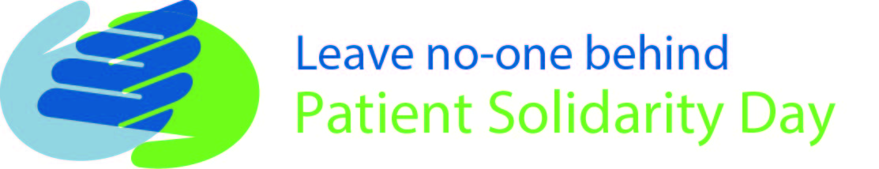
Pressure from patient movement for universal health coverage to become reality for all
From: the International Alliance of Patients’ Organizations
Embargoed until 00:01 GMT Saturday 5 December 2015

On Saturday 3 December, a global patient movement will rally together on Patient Solidarity Day in a united call for patient-centred universal health coverage for all by 2030.
Leading patient organizations across the world are expected to join forces on Saturday to hold governments and health systems to account. The campaign, run by the International Alliance of Patients’ Organizations (IAPO), urges decision-makers to demonstrate their commitment to universal health coverage in a bid to build patient-centred health systems that leave no-one behind.
Goal 3.8 of the Sustainable Development Goals calls for universal health coverage for all. In September 2015, UN Member States committed to developing national frameworks to achieve patient-centred universal health coverage, promising: “As we embark on this collective journey, we pledge that no-one will be left behind”.
On Saturday, patient groups will celebrate Patient Solidarity Day by calling for this commitment to be translated from paper into action. Universal health coverage will only be truly patient-centred when health services are universally accessible, affordable and of high quality. IAPO has developed a set of seven principles that need to be at the heart of health systems and services to ensure that universal health coverage is achieved [see note 4].
From lobbying Ministries of Health in Latin America, free legal aid clinics in Africa, through to a rallying meeting of over 2,000 patients and stakeholders in South East Asia, patient groups around the world are keeping up the pressure to ensure that the commitment to universal health coverage for all by 2030 is kept.
The key to ensuring that no-one is left behind is collaborative decision-making based on genuine patient involvement. Robust and sustainable action is needed from all stakeholders globally to develop patient-centred universal health coverage.
Jolanta Bilińska, IAPO’s Chair, said:
“Patient Solidarity Day 2016 is an opportunity for patients around the world to come together and unite in a call for a patient-centred universal health coverage, as promised by 194 Member States in September 2015. The Day is a reminder of the global voice that we have as patients and how we must use it to hold stakeholders to account.
“To be genuinely patient-centred, universal health coverage must involve everyone and be based on healthcare that is universally accessible, affordable and of high quality. It is with this in mind that we must act to ensure that no-one is left behind by 2030.”
Piga Fernandez, GIST Chile Fundación, Chile said:
“Patient Solidarity Day is an opportunity for patients around the world to unite and be the voice of many patients that need treatments that the health systems in their countries do not cover.”
Christian Locka, Action for Humane Hospitals, Cameroon said:
“In several African countries, including my own, patients are considered clients that pay medical care without having the right to examine the quality of care. With a focus on healthcare centred on the patient, Patient Solidarity Day is an important advocacy tool which should ultimately put the patient before, during and after public health policies.”
With thirteen years to go, we cannot release the pressure on governments, international organizations, industry and other stakeholders. Through this whole-society initiative, the patient movement will keep demanding patient-centred universal access for all to ensure that no-one is left behind.
--ENDS--

Notes to editors
For more information please contact Victoria Gilbert, Victoria@iapo.org.uk, 020 7250 8279 or Antonio Ciaglia, Antonio@iapo.org.uk , 020 7250 8278 and visit https://www.iapo.org.uk/patient-solidarity-day
- Patient Solidarity Day, now co-ordinated by the International Alliance of Patients’ Organizations, was first launched in 2011 by the Morris Moses Foundation. 2014 marked the first year that the Day was celebrated across all six continents. Last year, 108 organizations from 32 countries took part in of Patient Solidarity Day
- Sustainable Development Goal 3.8: “Achieve universal health coverage, including financial risk protection, access to quality essential health-care services and access to safe, effective, quality and affordable essential medicines and vaccines for all”. For further information, see link: https://sustainabledevelopment.un.org/sdg3
- The 194 UN Member States agreed to the Resolution A/RES/70/1 on 25 September 2015. Article 26 called for “universal health coverage and access to quality health care. No one must be left behind”
- The International Alliance of Patients’ Organizations has developed a set of seven principles that need to be at the heart of health systems to facilitate universal health coverage. For the full principles, see here: https://www.iapo.org.uk/universal-health-coverage
- World Health Organization Regional Office for Africa has officially endorsed Patient Solidarity Day
- Patient Solidarity Day supports Universal Health Coverage Day which will is held on 12 December every year to mark the UN passing of a landmark resolution endorsing UHC. For more information, see here: http://universalhealthcoverageday.org/welcome/

Social media:
- Thunderclap: https://www.thunderclap.it/projects/49023-leave-no-one-behind-psd2016
- Twitter: @PatientSolDay #PSD2016
- Facebook: http://www.facebook.com/patientsolidarityday

About the International Alliance of Patients’ Organizations (IAPO):
- IAPO is a unique global alliance promoting patient-centred healthcare worldwide
- IAPO has 276 members spanning over 71 countries and 51 condition areas
- IAPO’s vision is that patients throughout the world are at the centre of healthcare
- IAPO is committed to building cross-sector alliances and ensuring that patients play an active role in decision-making processes in healthcare by working collaboratively with key stakeholders, including medical and health professionals, policy-makers, academics, researchers and industry representatives.

